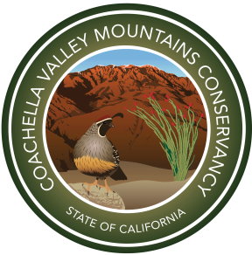 Coachella Valley Mountains Conservancy

grant application workshops for its
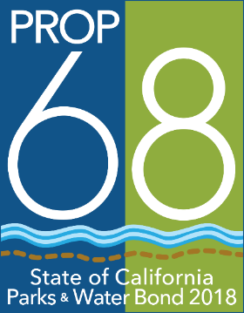
Proposition 1 and Proposition 68 Programs
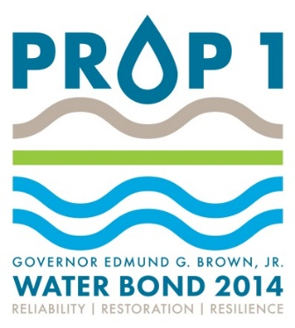
Tuesday, March 26, 2 p.m. | CVMC, 73710 Fred Waring Drive, # 115, Palm Desert
Wednesday, March 27, 2 p.m. | Coachella Library, 1500 6th Street, Conf. Rm. 2, Coachella
Thursday, March 28, 2 p.m. | Carl May Community Center, 11711 West Dr., Desert Hot Springs

Proposition 1 funds projects that implement the California Water Plan in the Coachella Valley.
Proposition 68 grants support projects that enhance access to outdoor recreation, preserving cultural or historical resources or respond to climate change.

Conservancy staff will be present at each workshop to provide information about eligible projects and the application process.

For further information:
Coachella Valley Mountains Conservancy
73-710 Fred Waring Drive, Suite 112
Palm Desert, CA 92260
(760) 776-5026
www.cvmc.ca.gov

